Unit 1: Counting and Probability MDM4U

Lesson Outline

Big Picture

Students will:
- solve problems involving probability of distinct events;
- solve problems using counting techniques of distinct items;
- apply counting principles to calculating probabilities;
- explore variability in experiments;
- demonstrate understanding of counting and probability problems and solutions by adapting/creating a children’s story/nursery rhyme in a Counting Stories project;
- explore a significant problem of interest in preparation for the Culminating Investigation.
Day | Lesson Title | Math Learning Goals | Expectations
1–2 | Mathematical Probability  (lessons not included) | - Investigate probabilities generated from experiments, e.g., spinners, sampling, numbered cubes, coins, cards, and use mathematical vocabulary, e.g., sample space, outcomes, events, trials, theoretical probability, experimental probability, mutually exclusive, non-mutually exclusive, independent and dependent events, complement, and notation (e.g., P(A), P(~A), P(A and B), P(A or B), P(A | B)) in contexts involving simple counting (e.g., where the sample space is given) and tools (e.g., tree diagrams, organized lists, Venn diagram).  - Determine whether two events are independent or dependent and whether one event is conditional on another.  - Recognize that the sum of the probabilities of all possible outcomes in the sample space is 1. | A1.1, A1.2, A1.3, A1.5, A1.6
3 | Counting Tales | - Introduce and understand one culminating project, Counting Stories Project, e.g., student select children’s story/nursery rhyme to rewrite using counting and probability problems and solutions as per Strand A.  - Create a class critique to be used during the culminating presentation. | E2.3, E2.4  CGE 2b
4–5 | Using Simulations to Show Variability  (lessons not included) | - Determine, through investigation using class-generated data and technology-based simulation models, the tendency of experimental probability to approach theoretical probability as the number of trials in an experiment increases.  - Graph the experimental probability versus the number of trials, and describe any trend. | A1.4
6 | Counting Arrangements and Selections  (lesson not included) | - Solve problems that progress from small sets to more complex sets using lists, tree diagram, role play to establish the need for a more formal strategy.  - See examples where some of the distinct objects are used and where all the distinct objects are used.  - Discuss how counting when order is important is different from when order is not important to distinguish between situations that involve the use of permutations and those that involve the use of combinations. | A2.1
Day | Lesson Title | Math Learning Goals | Expectations
7 | Counting Permutations  (lesson not included) | - Develop, based on previous investigations, a method to calculate the number of permutations of all the objects in a set of distinct objects and some of the objects in a set of distinct objects.  - Use mathematical notation, e.g., n!, P(n, r) to count. | A2.1, A2.2
8 | Counting Combinations  (lesson not included) | - Develop, based on previous investigations, a method to calculate the number of combinations of some of the objects in a set of distinct objects.  - Make connection between the number of combinations and the number of permutations.  - Use mathematical notation (e.g., ) to count  - Ascribe meaning to .  - Solve simple problems using techniques for counting permutations and combinations, where all objects are distinct. | A2.1, A2.2
9 | Counting Stories Project  (lesson not included) | - Use counting and probability problems and solutions to create first draft of Counting Stories Project. | A1.1, A1.3, A1.5, A1.6, A2.1, A2.2, A2.3
Day | Lesson Title | Math Learning Goals | Expectations
10–11 | Pascal’s Triangle  (lessons not included) | - Investigate patterns in Pascal’s triangle and the relationship to combinations, establish counting principles and use them to solve simple problems involving numerical values for n and r.  - There is only one way to choose all of the elements (i.e., ).  - There is only way to choose none of the elements  (i.e., ).  - There are n ways to choose one element from n elements (i.e., ).  - Choosing r elements from n elements is the same as choosing n–r elements from n elements  (i.e., ) (e.g., Choosing 3 girls from 8 girls for a committee is the same as choosing 5 girls not to be on the committee).  - The number of collections of any size from n elements is 2^{n} (i.e., )  (e.g., the number of different playlists selected from 10 tunes is 2¹⁰).  - The total number of selections of r elements from n elements is made up of selections that either include a particular element or not (i.e., ) (e.g., the number of unordered playlists with 5 tunes chosen from 10 tunes either includes a specific tune or not. If it includes it, there are ways of choosing the remaining tunes. If it doesn’t include it, there are ways of choosing the five tunes. So is the number of ways of choosing 5 tunes from 10, which is.).  - Investigate pathway problems. | A2.4
12 | Mixed Counting Problems  (lesson not included) | - Distinguish between and make connections between situations involving the use of permutations and combinations of distinct items.  - Solve counting problems using counting principles – additive, multiplicative. | A2.3
Day | Lesson Title | Math Learning Goals | Expectations
13 | Probability  (lesson not included) | - Solve probability problems using counting principles involving equally likely outcomes, e.g., two cards are drawn randomly from a standard 52-card deck. What is the probability that the two cards are both aces if the first card is replaced? If the first card is not replaced? | A2.5
14 | Counting Stories Project  (lesson not included) | - Complete final version of Counting Stories Project. | A1.1, A1.3, A1.5, A1.6, A2.1, A2.2, A2.3, A2.4, A2.5  F2.4
15 | Culminating Investigation  (lesson not included) | - Identify a significant problem of interest for Culminating Investigation.  - Brainstorm ideas, e.g., mind mapping, for organization and analysis of data related to a related significant problem. | E1.1
16–17 | Jazz
18–19 | Summative

Unit 1: Day 3: Counting Tales |  |  |  |  | MDM4U
  75 min |  | Math Learning Goals  - Introduce and understand one culminating project, Counting Stories Project, e.g., student select children’s story/nursery rhyme to rewrite using counting and probability problems and solutions as per Strand A.  - Create a class critique to be used during the culminating presentation. |  |  | Materials  - BLM 1.3.1–1.3.5  - Notebook  software  - presentation software
Assessment
Opportunities
 | Minds On… | Whole Class → Webbing Ideas  Lead students in a brainstorming session to generate a list of probability terms introduced thus far in the unit. Refer to Sample Mathematical Terminology Web (BLM 1.3.1).  Students construct a class mind map to make visual connections amongst the various terms, using interactive whiteboard software, SMART Ideas™ or chart paper and markers.  Whole Class → Introduction of Project  Read a children’s story that illustrates a different perspective or has used mathematical terms, e.g., The True Story of the 3 Little Pigs, by Jon Scieszka (ISBN 0-670-82759-2), Fractured Math Fairy Tales (ISBN 0-439-51900-4).  Using BLM 1.3.2, introduce the Counting stories project to students, and discuss the description of the task and the assessment rubric (BLM 1.3.3). |  | Students make connections between terms, concepts and principles of probability and counting using a Mind Map (Think Literacy, Cross-Curricular Approaches, Mathematics,  Grades 7–12, p. 77)  As students write portions of the story, be attentive to the appropriateness of the story line. Encourage Character Education Traits, e.g., the wolf is not portrayed as a bully.  BLM 1.3.5 is an example of an extension to the story.  The Counting Story Project could be a multi-disciplinary e.g., Math/English, Math/Art project.
 | Action! | Whole Class → Counting Story Development  Using the SMART™ Notebook file, PowerPoint files, or BLM 1.3.4, and BLM 1.3.5 develop the counting story exemplar with student input. At the end of the presentation, model writing a component of the story with student input.  Small Groups → Further Development of Counting Story  In small groups, students complete an additional component of the story, e.g., independent events, dependent events, mutually exclusive events, non-mutually exclusive events or complementary events. Ensure that each group completes a different missing component, including mathematical justification.  The Math Processes/Observation/Checkbric: Observe students as they use a variety of computational strategies, make connections, and communicate their reasoning to complete components of the story; prompt students as necessary.
 | Consolidate Debrief | Whole Class → Gallery Walk  Each group shares their completed component of the story in a gallery walk. (Each group’s work is displayed and students walk around to read each other’s component parts.)  Think/Pair/Share → Brainstorming  Students generate criteria for critiquing stories during the final presentation gallery walk, e.g., math content matches story, story is engaging, illustrations help with understanding. Create a class critique for the presentations, using the criteria agreed on.
Application |  | Home Activity or Further Classroom Consolidation  Select or create a story to begin your Counting Story Project. Begin to integrate mathematical components of the story already discussed in this unit. |  | Students continue to add to this project as they learn new concepts.

1.3.1: Sample Mathematical Terminology Web
for Counting Stories Project

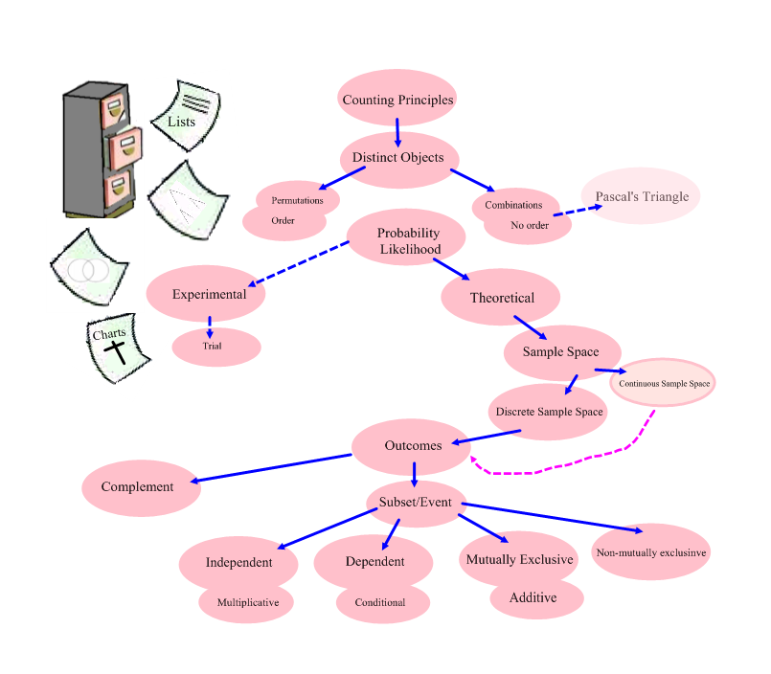

1.3.2: Counting Stories Project

You will re-write or create a children’s story, fairy tale, nursery rhyme, or song so that it includes probability and counting concepts and principles. The mathematics you introduce in the story must connect to the context of the story, and provide opportunities for decision making on the part of the characters within the story. The mathematics may be complex but try to keep the story simple. The assessment of this assignment will focus on the mathematics within the story line and the integration of narrative and mathematical forms in the story.

The following criteria will be assessed:

1. At least 12 of the following 19 concepts/principles are used to describe the decisions that the character(s) are asked to make.

- Additive Principle | - Combinations (no order)
- Complementary Events | - Conditional Probability
- Counting Techniques | - Dependent Events
- Events | - Experimental Probability
- Independent Events | - Multiplicative Principle
- Mutually Exclusive Events | - Non-Mutually Exclusive Events
- Outcomes | - Pascal’s Triangle
- Permutations (order) | - Sample Space
- Subset | - Theoretical Probability
- Trials

2. Appropriate organizational tools, e.g., Venn diagram, charts, lists, tree diagrams, are used and illustrated.

3. Diagrams, words, and pictures illustrate the tools and computational strategies used and the choices available to the character(s).

Feedback on this assignment will include:
- Peer critiques of your story
- A level for each of the criteria in the Counting Stories Rubric

You will read the stories of others during a class gallery walk. Using the critiques developed by the class, each student critiques two of the stories of others, selected by random draw. These critiques provide peer feedback to the author of the story.

1.3.3: Counting Stories Project Rubric

Criteria | Level 1 | Level 2 | Level 3 | Level 4
Problem Solving
Applying mathematical processes and procedures correctly to solve the problems in the story | - correctly applies some of the mathematical processes and procedures with major errors | - correctly applies many of the mathematical processes and procedures with some errors | - correctly applies the mathematical processes and procedures with few errors | - correctly applies the mathematical processes and procedures with precision and accuracy
Selecting Tools and Computational Strategies
Selecting and using tools and strategies to organize the mathematics presented in the story | - selects and applies the counting organizers (Venn diagram, charts, lists, tree diagrams) with major errors or omissions | - selects and applies the counting organizers (Venn diagram, charts, lists, tree diagrams) with minor errors or omissions | - selects and applies the counting organizers (Venn diagram, charts, lists, tree diagrams) accurately | - selects and applies the most appropriate counting organizers (Venn diagram, charts, lists, tree diagrams) accurately
Connecting
Connecting the concepts/principles of counting and probability to the story line | - incorporates permutations, combinations, and probability with weak connections to the story line | - incorporates permutations, combinations, and probability with simple connections to the story line | - incorporates permutations, combinations, and probability with appropriate connections to the story line | - incorporates permutations, combinations, and probability with strong connections to the story line
Representing
Creating an appropriate variety of mathematical representations within the story | - few representations are embedded in the story | - some representations are embedded in the story | - an adequate variety of representations are embedded in the story | - an extensive variety of representations are embedded in the story
Communicating
Using mathematical symbols, labels, units and conventions related to counting and probability correctly across a range of media | - sometimes uses mathematical symbols, labels, and conventions related to counting and probability correctly within the story | - usually uses mathematical symbols, labels, and conventions related to counting and probability correctly within the story | - consistently uses mathematical symbols, labels, and conventions related to counting and probability correctly within the story | - consistently and meticulously uses mathematical symbols, labels, and conventions related to counting and probability correctly and in novel ways within the story
Integrating narrative and mathematical forms of communication in the story | - either mathematical or narrative form is present in the story but not both | - both mathematical and narrative forms are present in the story but the forms are not integrated | - both mathematical and narrative forms are present and integrated in the story | - a variety of mathematical and narrative forms are present and integrated in the story and are well chosen

1.3.4: Counting Stories Project Presentation File

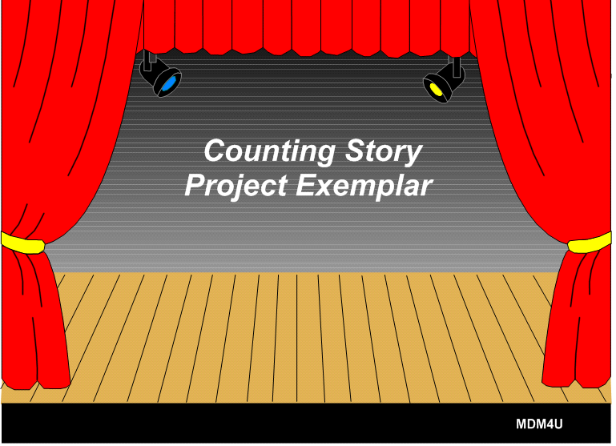 | 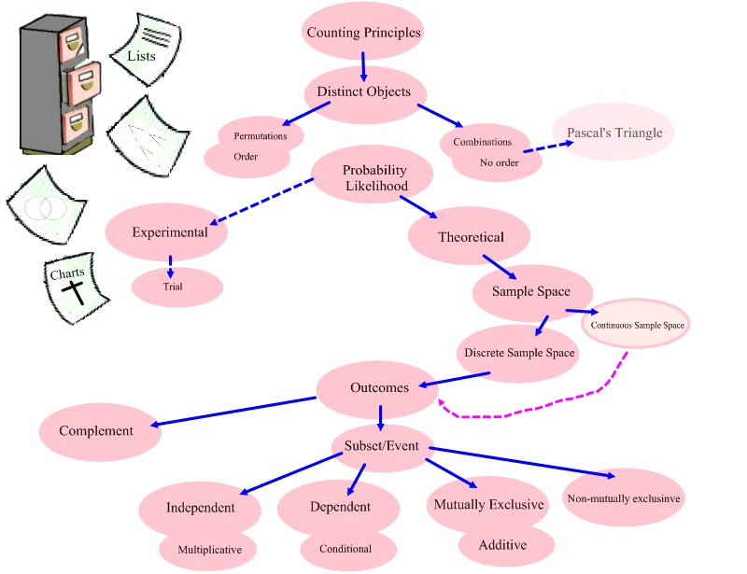
Slide 1 | Slide 2
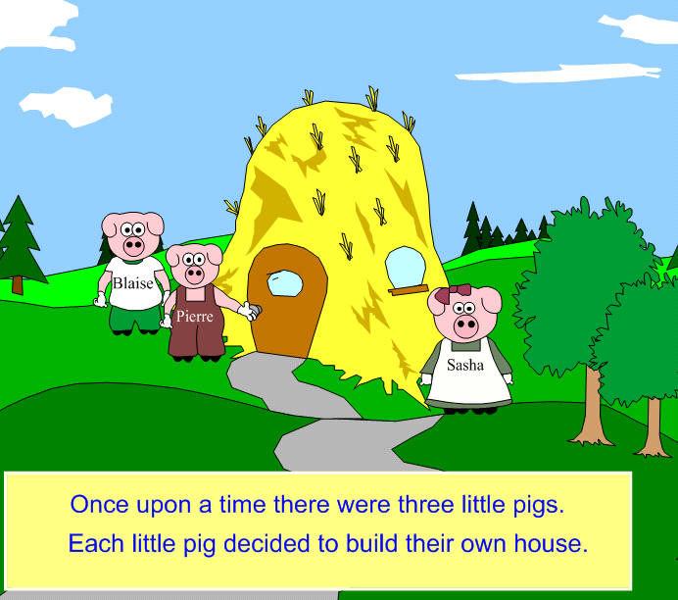 | 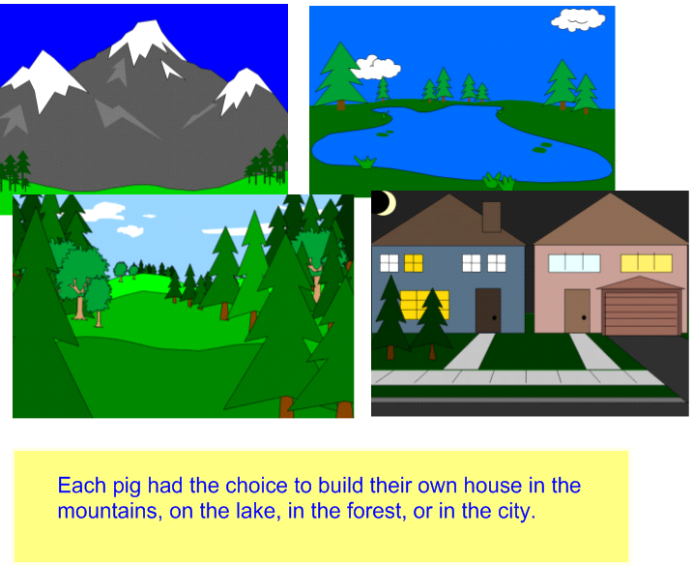
Slide 3 | Slide 4
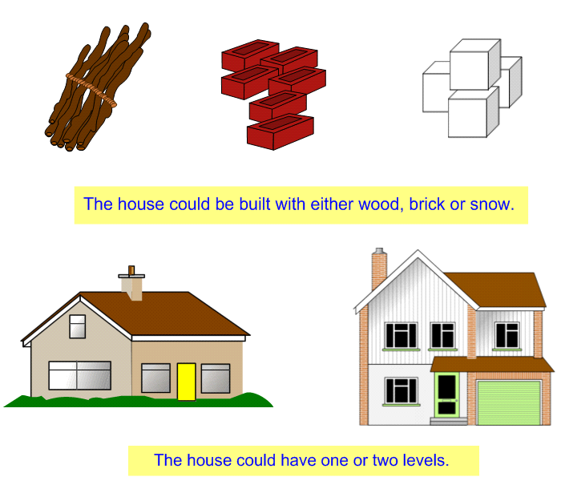 | 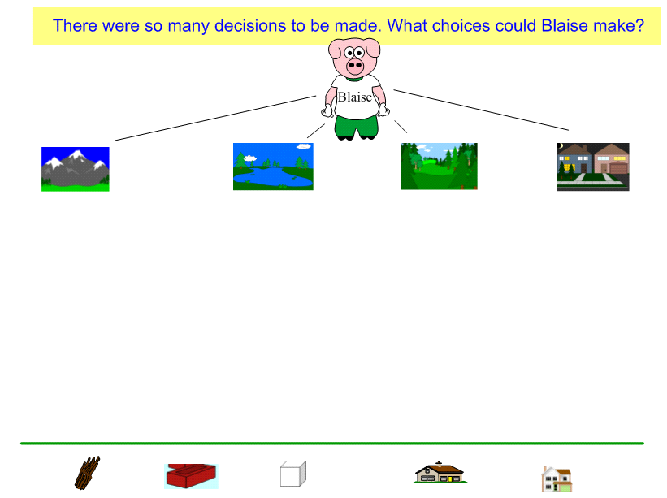
Slide 5 | Slide 6

1.3.4: Counting Stories Project Presentation File (continued)

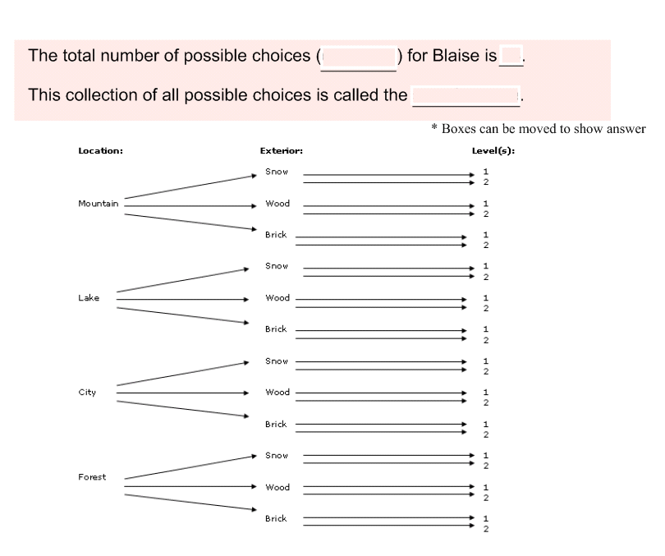 | 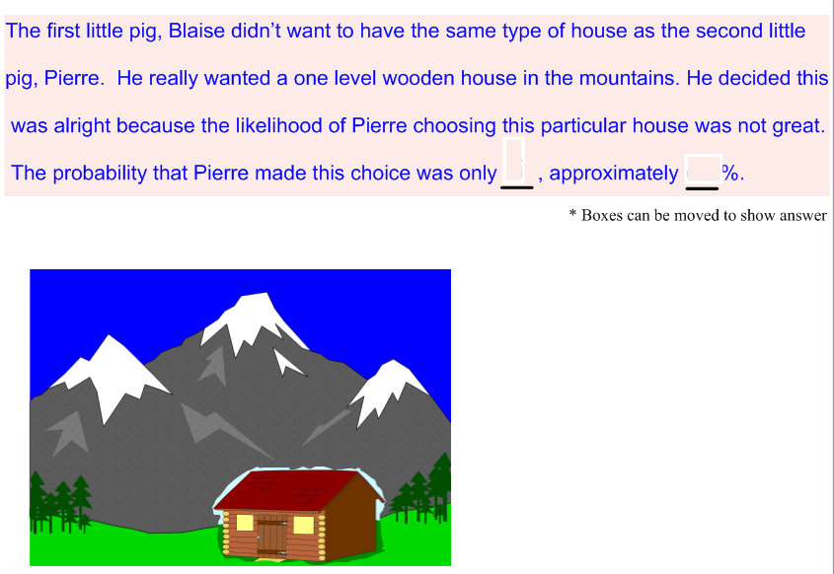
Slide 7 | Slide 8
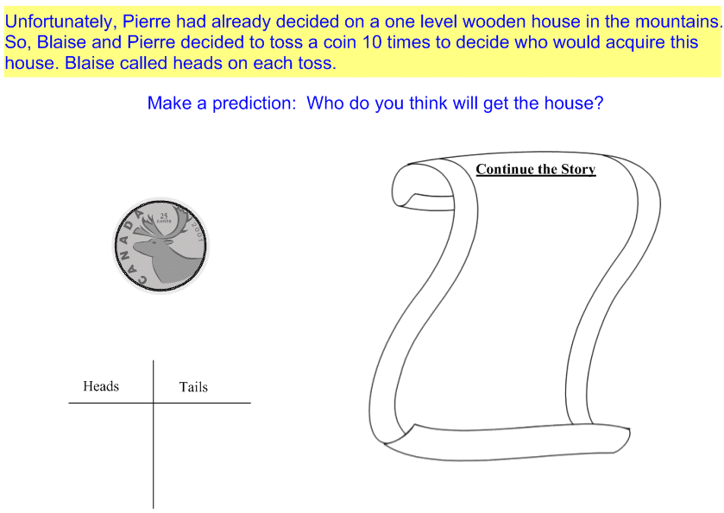 | 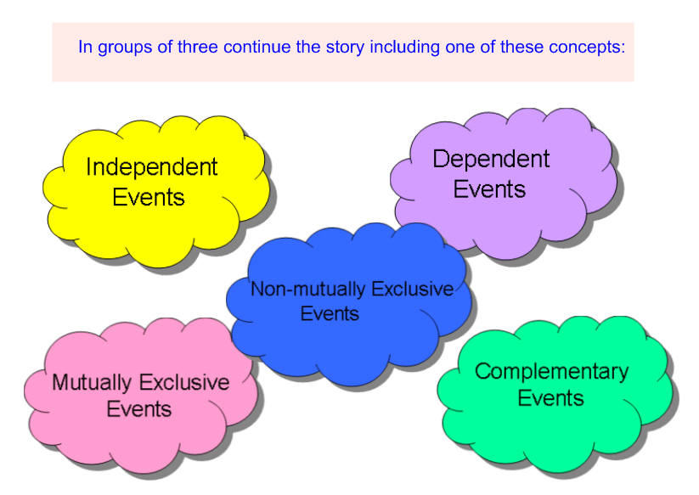
Slide 9 | Slide 10

1.3.5: Sample Stories Extensions

Non-Mutually Exclusive Events
The third little pig, Sasha knows she will be happy with a house that is either in the forest or built of wood. How many possible houses can she have?

Her choice is far more likely to happen. The number of houses satisfying her event criteria
was 12.

Using the additive principle, Sasha observes that building a house in the forest made of wood are non-mutually exclusive events since the subset of building of wood in the forest is not empty.
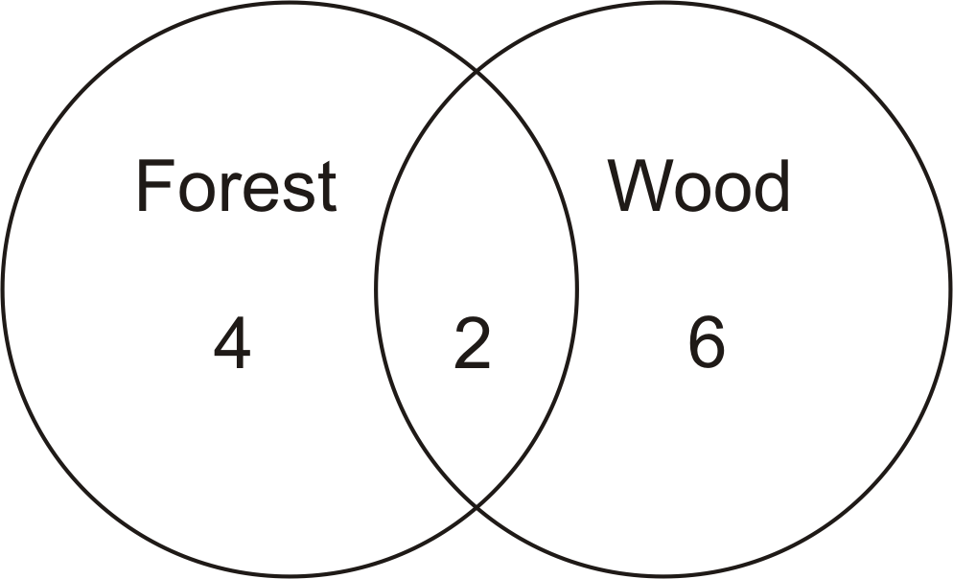

Independent Events
The probability that Sasha chooses a house in the forest built of wood is . The probability that Pierre chooses his one level house in the mountains is . According to the multiplicative principle, the probability of Sasha’s choice and Pierre’s choice occurring together is since they are independent events.

